Youth Enrichment Services Track Program chosen for New Balance grant

July 30, 2014
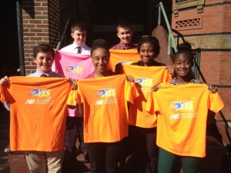

The YES Track & Field Program is pleased to have been chosen by the New Balance Foundation for a grant through the NB SparkStart Initiative. NB SparkStart is a global initiative focused on improving the health, well-being and self-esteem of children through movement. YES Track and Field was a clear match for the initiative as a program that both introduces Boston-area youth to the principles of track and field and helps them grow into strong and confident athletes.
Noreen Bigelow, Charitable Programs Assistant of the New Balance Foundation says that the SparkStart initiative began because,“The NB Foundation believes that finding and pursuing your movement spark at an early age empowers kids to build confidence, set and accomplish personal goals and nurtures a healthy body and mind.” For the upcoming year, New Balance will “continue to partner with YES and their running programs to get youth active and engaged in their overall health and wellness.”
YES looks forward to using the New Balance SparkStart grant to grow the Track and Field program beyond its current reach of 300 participants. Additionally, YES Track and Field will use the grant to expand its outreach to other communities in the Boston area.
For more information on New Balance’s SparkStart Initiative, visit their website here.

